1. Quick Start

Ensure you have Android Version 5.0 or later installed on your mobile device.

Download the latest foreman.apk from the releases tab.

Open the file and install the app on your mobile device.

Ensure the time zone of your device is the same as the domain system.

Click the icon to start the app. The GUI should appear in a few seconds.

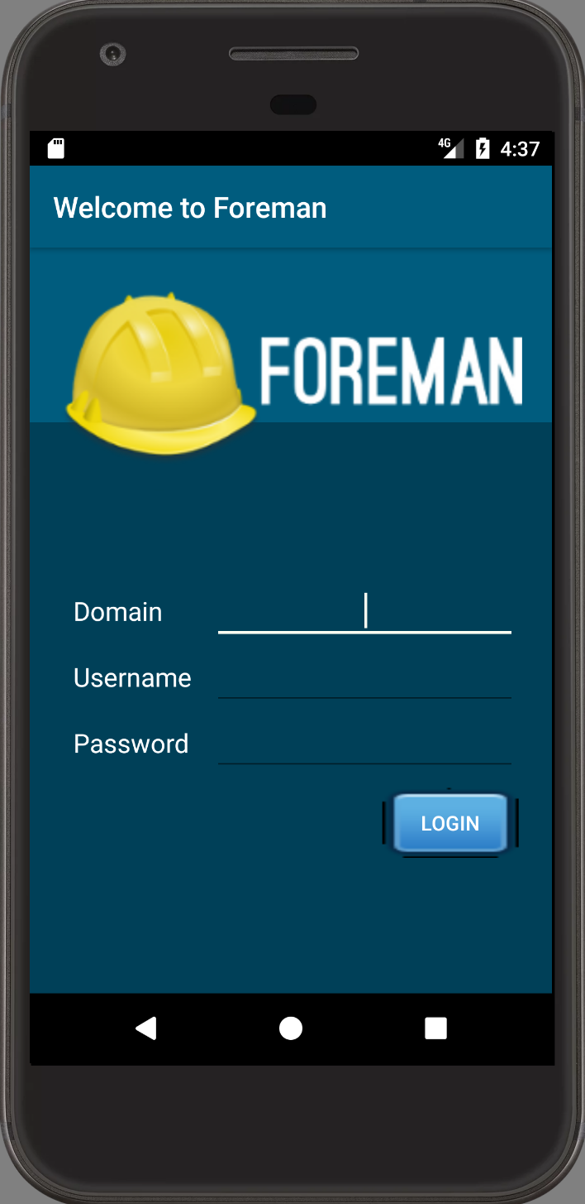

Type the domain (url), username and password. Then click Login.

If the url, the username and the password are correct, the app will go to the dashboard page.

Refer to Features section below for details of functions.

1. Features

* Monitor Page

The following 3 components can be switched using navigation drawer, opening by slide the screen from left to right or clicking the button on the tool bar.

1. Dashboard

There are four components in the dashboard page. The data are updated every 30 seconds.

* Host Configuration Chart

This pie chart illustrating the numerical proportion of numbers of hosts in different status.

The percentage of the most kinds of hosts are shown above the chart.

* Host Configuration Status

This table showing the number of hosts in different status

The color code of the same kind of hosts in the status table and chart are corresponding.

* Run distribution in the last 30 min

This histogram shows the distribution of numbers of hosts which have run and reported with in the last 30 minutes. The time interval is 3 minutes.

e.g. The number of which the x-coordinate is 6 shows the number of hosts which reported within the last 3-6 minutes.

* Latest Event

This able shows nine latest events with its host and its status.

There are six status of a host. “A” means “applied”. “R” means “restarted”. “F” means “failed”. “FR” means “failed restarts”. “S” means “skipped”. “P” means “pending”.

1. List of All Hosts

* This page shows a list of hosts on the server.
* Each host is listed as an icon showing its status, its name and a button “EDIT”.
* Click the button to go to the page to view all parameters of the host and editing them.

1. List of All Host Groups
   * + - This page shows a list of host groups on the server.
       - Each host group is listed as its name, a button “ALL” and a button “EDIT”.
       - Click the button “ALL” to go to the page viewing all hosts in the host group. The page is similar to the list of all hosts.
       - Click the button “EDIT” to go to the page to view all parameters of the host and editing them.

* Editing Page
* The page contains all puppet classes of a host or a host group.
* Under each puppet class, the name of parameters and the conditions and values are listed.
* There is an icon beside the name of the parameters showing its condition and when clicking it, a window showing the information of original value of the parameter will pop up. The Original Value Info window contains description, type, matcher and inherited value of the parameter.
* There are three kinds of values for parameters.

1. Inherited Value.

By default, a host will inherit value from its host group. A host group will inherit value from its parent, and if it is not a child group of the others, it will inherit from the default value. In this condition, the value will show the value it inherits and is not editable.

1. Puppet Default

The parameter will use the value of Puppet. In this condition, the value will show nothing and is not editable. The Original Value Info window will show “Optional parameter without value. Will not be sent to Puppet”.

1. Override

The parameter will use the value behind, which is editable in this condition.

* There are two buttons at the bottom of the page. One is “SUBMIT”, the other is “CANCEL”. Click “SUBMIT” to confirm the changes and send it to the server. Click “CANCEL” to release all changes and return to the last page.